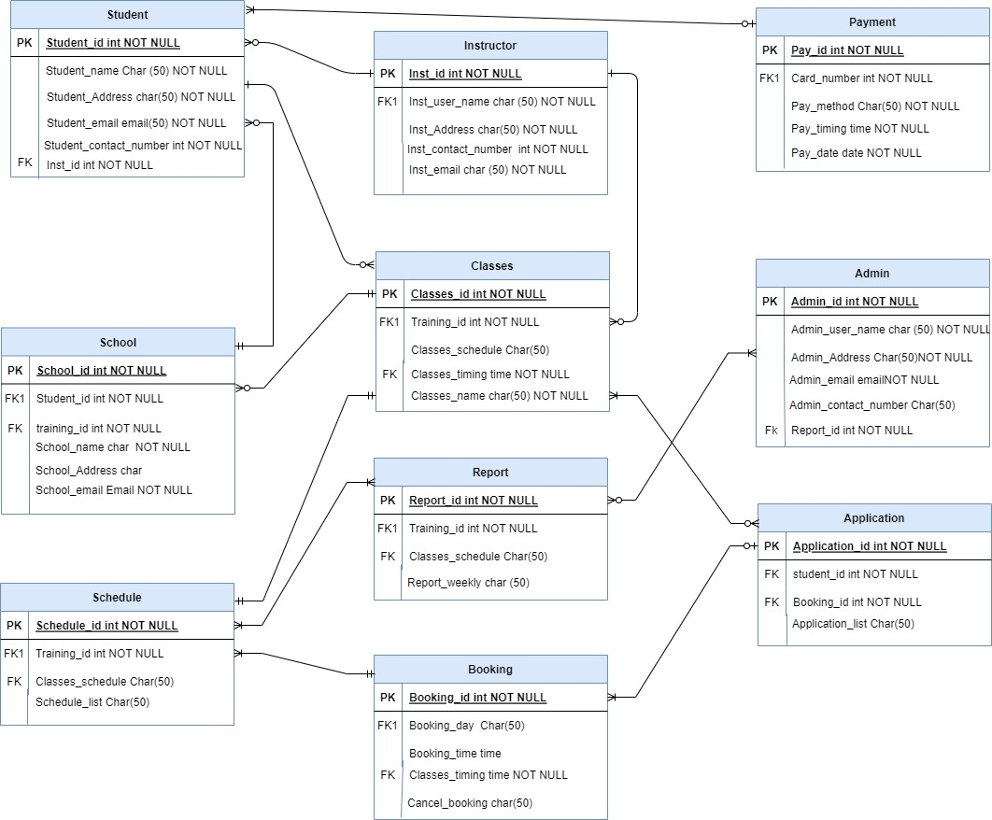**Relational Entity Relationship Diagram**